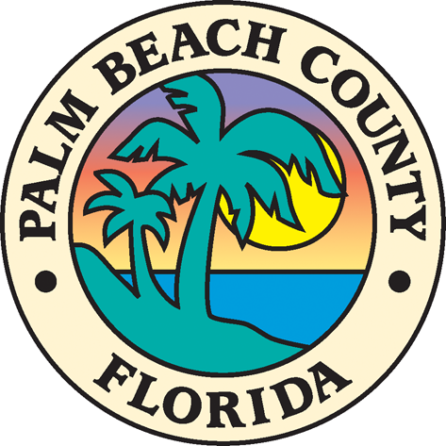

PALM BEACH COUNTY
OFFICE OF COMMUNITY REVITALIZATION

Neighborhood Engagement and Transformation (NEAT) Grants Program
CONTRACT PAYMENT REQUEST FORM

Date: _________________

Contract number:_________________

Organization Name: ______________________________________________

Project Coordinator: ___________________________________________

Address: _______________________________________________________

Requested Items: _______________________________________________

Vendor registration #_______________________

Amount being requested: $______________________

Recipient of disbursed funds:

Name: __________________________________________________________

Address: _______________________________________________________

Telephone #: _____________________________________________________

Vendor registration #_____________________________________________
Click Here for vendor # https://www.pbc.gov/pbcvendors

Attach original receipt(s) and/or invoice(s) and bank statements showing purchases ( if applicable)

Attach Contractor/Subcontractor Certificate of Insurance (if applicable)

Email to: cmathews@pbc.gov or Deliver / Mail to:

Chrystal Mathews, Senior Planner
Office of Community Revitalization
2300 North Jog Road
West Palm Beach, FL 33411
561-233-5565

